Dis-ME-Isr-Mother Goddess

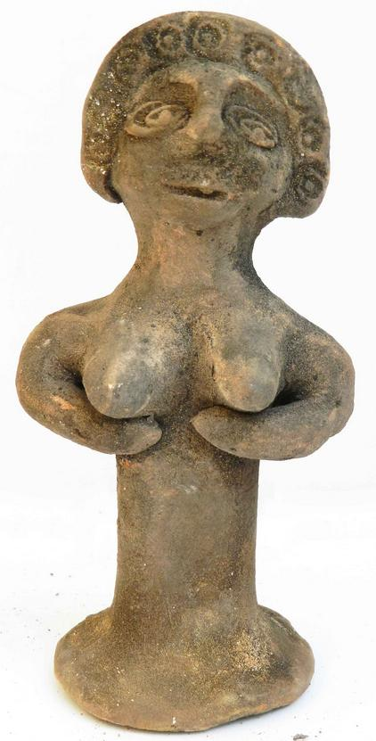 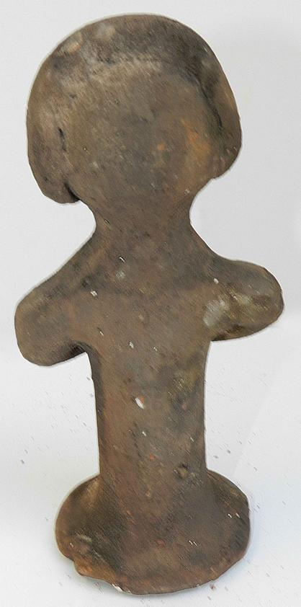

Height: 14.5 cm = 5.7 Inches

- Width: 7.5 cm = 3 Inches

- Weight- 0.275 kg

**Condition;** Replica in Good condition as shown

The original item Found in the Judean desert southern Jerusalem, Israel